**Summary of Progress in the Course Project - "Multi-Agent Artificial Intelligence Systems":**

**Objective of the Experiment:**

The aim of this experiment is to examine how the addition of the "No Vote" option affects people's voting behavior. Under what circumstances does this option influence voting? When does it not? Do we observe any impact at all?

**Experimental Design:**

To answer these questions, we are examining multiple scenarios by dividing the questionnaires into two categories:

1. Questionnaire with 3 candidates + the option to not vote.
2. Questionnaire with 2 candidates + the option to not vote.

**Scenarios for Option 1:**

- For different numbers of survey participants (107, 1003, 10007)

- For different benefits of choosing the "No Vote" option (0.03, 0.05, 0.07 ₪):

1. What happens when there is a small difference between all candidates?
2. What happens when the second most preferred candidate leads by a small margin over the most preferred candidate and a large margin over the least preferred candidate?
3. What happens when the least preferred candidate leads by a small margin over the second most preferred candidate and a large margin over the most preferred candidate?
4. What happens when the least preferred candidate leads by a small margin over the most preferred candidate and a large margin over the second most preferred candidate?
5. What happens when the most preferred candidate leads by a small margin over the least preferred candidate and a large margin over the second most preferred candidate?
6. What happens when the least preferred candidate leads by a large margin over all other candidates?
7. What happens when the second most preferred candidate leads by a large margin over all other candidates?
8. What happens when the most preferred candidate leads by a large margin over all other candidates?

**Scenarios for Option 2:**

- For different numbers of survey participants (107, 1003, 10007)

- For different benefits of choosing the "No Vote" option (0.03, 0.05, 0.07 ₪):

1. What happens when the most preferred candidate leads by a small margin over the least preferred candidate?
2. What happens when the least preferred candidate leads by a small margin over the most preferred candidate?
3. What happens when the least preferred candidate leads by a large margin over the most preferred candidate?
4. What happens when the most preferred candidate leads by a large margin over the least preferred candidate?

**System Design:**

After designing the poll distributions as described above, I built a system that displays:

1. A graph showing the distribution of the poll (how many voted for each candidate)
2. 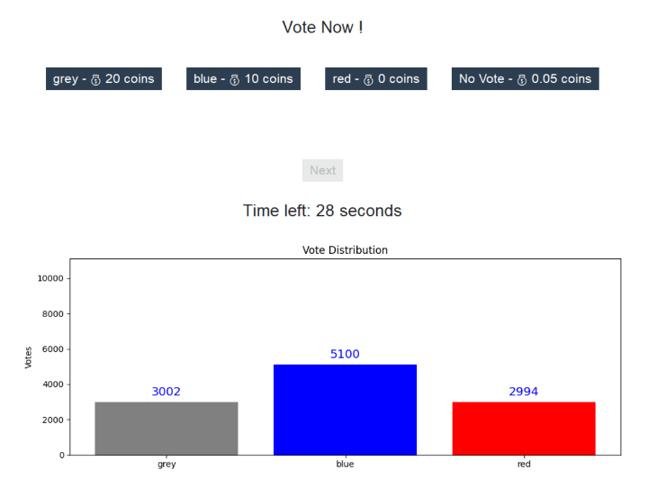The candidates and the benefit (prize) if the candidate chosen by the user wins.

**Future Research Plan:**

1. Presentation explaining the research to participants.
2. Conducting the experiment with a number of participants (approximately 50-100 participants).
3. Analyzing and investigating the results.
4. Drawing conclusions from the experiment.

תכנון הניסוי:

אנחנו יצרנו סקרים עם התפלגויות שונות של מצביעים. כאשר יש מספר קומבינציות:

- עבור גדלי מדגם שונים: 100 מצביעים, 10,100 מצביעים, 120,100 מצביעים, 1,000,000 מצביעים.

- עבור ערכים שונים של תועלת מן בחירת האפשרות "אי הצבעה" : 1,10,20 . כאשר יש פער גדול בין המועמד הכי פחות מועדף למועמד המועדף, התועלת עבור אפשרות "אי הצבעה" הוא: 1,2,3. עיקר הסיבה לכך היא לראות שגם עבור ערכים מאוד נמוכים במקרה אבוד שבו כמעט אין סיכוי למועמד המועדף של המצביע לנצח האם המצביע יבחר לא להצביע גם עבור תועלת מאוד נמוכה.

* 1. המועמד המועדף מוביל בפער גדול על המועמד השני- פער של מעל 30% מגודל המדגם.
  2. המועמד המועדף מוביל בפער בינוני על המועמד השני- פער של 10%-20% מגודל המדגם
  3. המועמד המועדף מוביל בפער קטן על המועמד השני- 1-5% מגודל המדגם.

לאחר מכן עיצבנו את מערכת הניסוי. כל משתתף בסקר יראה במסך מספר דברים:

1. גרף של התפלגות המצביעים. כמה מצביעים הצביעו לכל מועמד.
2. בחירה בין 3 אפשרויות: מועמד א, מועמד ב ואפשרות של "אי הצבעה"
3. ליד כל אפשרות ניתן לראות מה התועלת אם המצביע בחר במועמד המנצח/ שבחר באפשרות של "אי הצבעה" (הסתברות של 100% לקבל את התועלת בבחירה באפשרות זו)

**2. Related Work:**

The study of voting behavior and strategic voting is a well-established area in political science and economics. The addition of a "No Voting" option in polls adds a novel dimension to this field, warranting an examination of existing literature that informs our understanding of voter behavior in various contexts.

2.1 Voting Behavior and Strategic Voting

Theoretical models of voting behavior often distinguish between sincere voting, where individuals vote according to their true preferences, and strategic voting, where individuals vote in a way that maximizes their utility based on their expectations of other voters' behavior. Foundational works by Downs (1957) and Riker and Ordeshook (1968) have established the rational choice framework for understanding why individuals vote and how they might vote strategically. These models have been expanded by Myerson and Weber (1993), who introduced equilibrium concepts for voting under uncertainty.

Empirical studies, such as those by Blais et al. (2000) and Alvarez and Nagler (2000), have examined how voters behave in real-world elections, often finding evidence of strategic voting when voters are faced with information about the likely outcomes. Recent research by Bassi (2015) and Degan and Merlo (2011) has also explored how voters use polls to inform their strategic decisions, highlighting the impact of information on voter behavior.

2.2 Abstention and the "No Voting" Option

The phenomenon of voter abstention has been studied extensively, with scholars like Jackman (1987) and Lijphart (1997) exploring the reasons behind why individuals choose not to vote. The inclusion of a "No Voting" option in polls can be seen as a formalization of abstention within the decision-making framework. Studies by Franklin (2004) and Rubenson et al. (2007) have investigated the determinants of voter turnout, suggesting that factors such as voter fatigue, alienation, and indifference play significant roles in the decision to abstain.

Introducing a "No Voting" option may influence strategic voting behaviors by providing an additional choice for voters who are undecided or prefer to abstain. This aligns with the findings of Riker and Ordeshook (1968), who posited that the decision to vote is a function of the perceived benefits and costs of voting. By offering a "No Voting" option, the perceived costs of making a decision might be reduced, potentially altering the overall dynamics of voter behavior.

2.3 Experimental and Empirical Studies

Experimental studies have been instrumental in understanding voter behavior in controlled settings. Morton and Williams (2010) provide a comprehensive overview of experimental methods in political science, highlighting how laboratory experiments can isolate the effects of specific variables on voting behavior. Recent experiments by Agranov et al. (2018) and Blais et al. (2019) have used laboratory settings to investigate strategic voting and the impact of information on voter decisions.

In our study, we employ an experimental approach to assess how the "No Voting" option influences strategic voting in a poll-based environment. By conducting controlled experiments with participants, we aim to isolate the effects of this additional choice on voter behavior, providing empirical evidence to complement theoretical models